**Project Design Phase-I**

**Solution Architecture**

|  |  |
| --- | --- |
| Date | 24 October 2022 |
| Team ID | **PNT2022TMID**09930 |
| Project Name | Project - Real-Time River Water Quality Monitoring and Control System |
| Maximum Marks | 4 Marks |

**Solution Architecture:**

Alerts When The Quality Of Water Is Reduced

Stores The Data Into IBM Cloudant Db

Ph

Level And

Turbidity Of The

Water

Send Data To IBM IOT Watson Platform

Water

**Example –Solution Architecture Diagram:**



**CLOUD SERVICE**



**FAST SMS**

 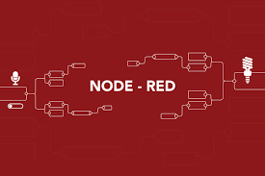 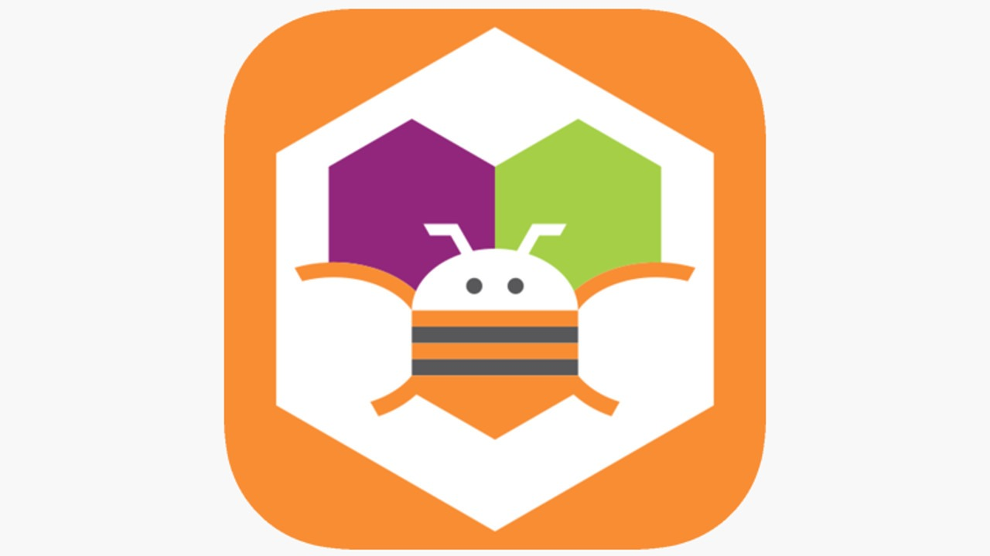 

**IOT DEVICE**

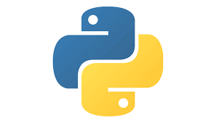

**USER**

**WEB UI**

**NODE-RED**

**IBM WATSON IOT PLATFORM**

**PYTHON CODE**

**PROJECT DESCRIPTION:**

* River water quality can be monitored by the web application.
* The web application and the user are interfaced.
* The pH level and the turbidity of the water can be monitored.
* If the water quality is not good then the authorities get alerted by the message.